PROGRAM 1:

import java.util.Scanner;

import java.io.\*;

public class pg1

{

public static void main(String[] args){

Scanner scan=new Scanner(System.in);

int t=scan.nextInt();

for(int i=0;i<t;i++){

long n=scan.nextLong();

System.out.println(n+" can be fitted in");

if(n>=-128 && n<=128)

System.out.println("byte");

if(n>=-32768 && n<=32767)

System.out.println("Short");

if(n>=-2147483648L &&n<=2147483647L)

System.out.println("int");

if(n>= -9223372036854775808L && n<=9223372036854775807L)

System.out.println("long");

}

}

}

OUTPUT:

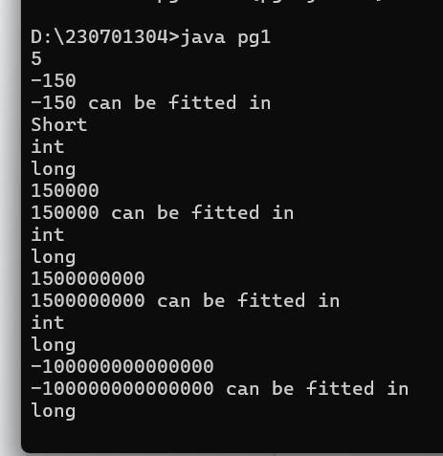

PROGRAM 2:

import java.util.Scanner;

import java.io.\*;

public class pg2

{

public static void main(String[] args)

{

Scanner scan= new Scanner(System.in);

int cents=scan.nextInt();

double dollar=cents/100.00;

System.out.format("The output be: %.2f",dollar);

}

}

OUTPUT:

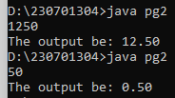

PROGRAM 3:

import java.util.Scanner;

import java.io.\*;

public class pg3

{

public static void main(String[] args)

{

Scanner scan= new Scanner(System.in);

double n=scan.nextDouble();

int m=(int)n;

System.out.print(m);

}

}

OUTPUT:

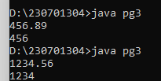

PROGRAM 4:

import java.util.Scanner;

import java.io.\*;

public class pg4

{

public static void main(String[] args)

{

Scanner scan= new Scanner(System.in);

int sal=scan.nextInt();

double per=scan.nextDouble();

double n=sal\*(per/100);

double ans=sal+n;

System.out.println("The new Salary: "+ans);

}

}

OUTPUT:

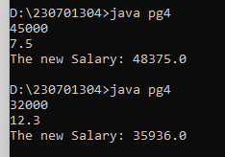

PROGRAM 5:

import java.util.Scanner;

import java.io.\*;

public class pg5

{

public static void main(String[] args)

{

Scanner scan= new Scanner(System.in);

int n=scan.nextInt();

int temp=n;

int rev=0,rem;

while(n!=0)

{

rem=n%10;

rev=rev\*10+rem;

n=n/10;

}

if(rev==temp)

{

System.out.println("The reversed number is "+rev+". It is the same as the original.");

}

else

{

System.out.println("The reversed number is "+rev+". It is not the same as the original.");

}

}

}

OUTPUT:

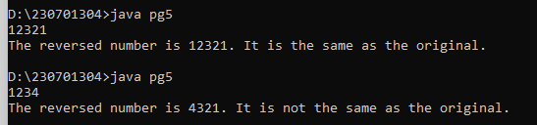

PROGRAM 6:

import java.util.Scanner;

import java.io.\*;

public class pg2

{

public static void main(String[] args){

Scanner scan=new Scanner(System.in);

int n=scan.nextInt();

for(int i=1;i<=n;i++){

for(int j=n;j>i;j--){

System.out.print(" ");

}

for(int k=1;k<=(2\*i-1);k++){

System.out.print("\*");

}

System.out.println();

}

for(int i=n-1;i>=1;i--){

for(int j=n;j>i;j--){

System.out.print(" ");

}

for(int k=1;k<=(2\*i-1);k++){

System.out.print("\*");

}

System.out.println();

}

}

}

OUTPUT:

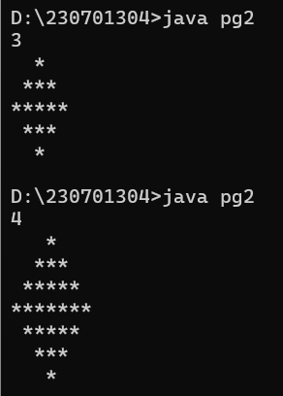

PROGRAM 7:

import java.util.Scanner;

import java.io.\*;

public class pg7

{

public static void main(String args[]){

Scanner scan=new Scanner(System.in);

int n=scan.nextInt();

for(int i=0;i<n;i++){

for(int j=0;j<n-i-1;j++)

System.out.print(" ");

for(int j=0;j<=i;j++)

System.out.print(" "+fact(i)/(fact(j)\*fact(i-j)));

System.out.println();

}

for(int i=n-2;i>=0;i--)

{

for(int j=n-i;j>0;j--)

System.out.print(" ");

System.out.print("1");

for(int j=i-1;j>=0;j--)

System.out.print(" "+fact(i)/(fact(j)\*fact(i-j)));

System.out.println();

}

}

public static int fact(int n){

if(n==0)

return 1;

return(n\*fact(n-1));

}

}

OUTPUT:

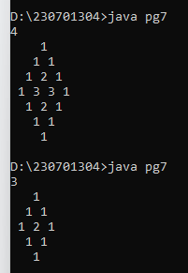

PROGRAM 8:

import java.util.Scanner;

import java.io.\*;

public class pg8

{

public static void main(String[] args){

Scanner scan=new Scanner(System.in);

int q=scan.nextInt();

for(int i=0;i<q;i++){

int a=scan.nextInt();

int b=scan.nextInt();

int n=scan.nextInt();

int sum=a;

for(int j=0;j<n;j++){

sum+=(int) Math.pow(2,j)\*b;

System.out.print(sum+" ");

}

System.out.println();

}

}

}

OUTPUT:

